Parish Profile
2017

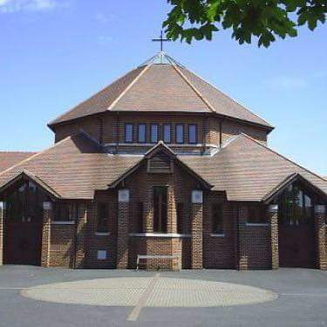

Church of the Ascension Penrith Road, Berwick Hills Middlesbrough TS3 7JR
A letter from the Bishop of Whitby

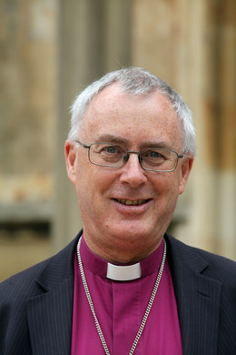
Thank you for looking at our parish profile.

In the pages that follow, you can see how the people of the parish of the Ascension describe their community and church, and the possibilities they see for moving forward in company with their new priest.

The parish was led for over 20 years by Canon David Hodgson, who died in office in October 2016. He was a much loved larger-than-life character who is greatly missed by parishioners and by colleagues across the diocese. David laid a secure foundation of sacramental worship, prayer and study, and that legacy is something that we would all want to see honoured in the future. The liturgical style of the parish’s formal worship is distinctively modern catholic, using the rites of the Church of England.

David combined his personal Traditionalist Catholic stance with a generous spirit of committed collaboration with clergy and parishes representing the spectrum of Anglicanism. The parish was designated to receive the extended episcopal care of the Bishop of Beverley, whilst maintaining close contact with the Archbishop and with me. In the time since David’s death there has been much prayerful thinking in the parish, in conjunction with the Bishop of Beverley and myself. Among the worshippers at the Ascension there are some who in conscience cannot receive the sacramental ministry of female clergy, and others who do not hold a Traditionalist position. Everyone involved in these conversations agrees that it would be damaging to the life and mission of the parish if this range of views were to become a cause of division, when there are opportunities to take God’s work in this community forward together. So, recognising the situation of the parish and the way in which positions of conscience are held and expressed, the decision has been taken that this appointment will only be open to male clergy ordained by male bishops, whilst the personal stance of candidates will not be a factor in the appointment — and that whilst, at least for the present, only male clergy should exercise sacramental ministry in the parish, the appointee will recognise the ministry and orders of other clergy, and work with them, irrespective of gender.

This is a parish with wonderful people and exciting opportunities. It shares the mix of characteristics typical of urban estates. There is a strong community feel. The church is generally regarded with respect, and there is scope for clergy to take a leading part in the development of community. New ventures and partnerships, involving churches and other agencies, are steadily making a positive difference in Middlesbrough, as can be seen from looking at the website of our Joint Venture with the Church Urban Fund, Together Middlesbrough & Cleveland.

This is a calling for a priest, a friend of Jesus, who will love God’s people, build up the core group of worshippers, imaginatively expand the range of accessible worship, and exchange supportive relationships with neighbouring parishes. Most of the parish’s residents have no regular contact with church, and so a major part of the priest’s task will be to explore ways to bridge the gap — knowing the people and being known by them, and equipping existing church people to be advocates and ambassadors of faith as they live out their daily lives. An important aspect will be to discern how an appropriate style and means of evangelism can be established, finding opportunities to show and explain how the people of Berwick Hills can glimpse God’s love and purpose.

This comes with prayers as you consider whether you may be the person God is calling to serve here.

Welcome to the Church of the Ascension, Middlesbrough!

The Ascension Life
We serve the three housing estates of Park End, Berwick Hills and Pallister Park in Middlesbrough, which were established in the post war years of the 1950’s. The parish covers an area of four square miles and has a population of about 17000 people. There are two other churches in this parish, the Baptist church and the Salvation Army.

There are three primary schools and an Academy for 11+ pupils. We have good relationship with two of the primary schools and the Academy has used our church building for Christmas services.
Behind the church is Ormesby Grange Care Home and we visit the residents. Two receive Holy Communion. Next to the church is a building which gives temporary refuge to the homeless.
There is a good shopping area close by with a supermarket, small shops, a chemist, post office, doctor’s surgery and a dentist. The Neptune Centre has sports facilities with a swimming pool and a library.

Hastings House has a number of flats for retired people and two members of our congregation have been instrumental in hosting events at Christmas and Easter when we have held services there.
The three estates are well set out with semi-detached and terraced housing, bungalows for the elderly and many have green areas plus two local parks.

Our worship is centred on the Sacrament of the Holy Communion and we have two Eucharist Services each week. On Sunday morning at 9.15 am attended by 25-30 people and Wednesday morning at 9.15 am attended by 6-8 people. Both services are followed by fellowship and coffee in the church hall.

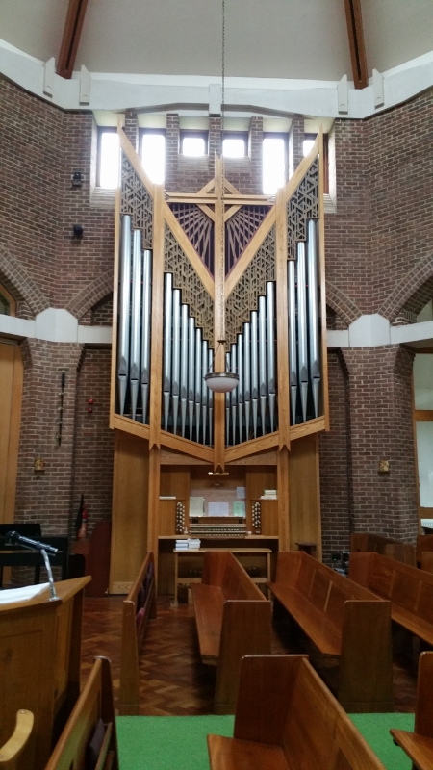
Our Church Organ

The worship in the church is lively and enthusiastic. The organist has been in post for 40 years but is keen to work co-operatively with the priest and is open to using a variety of styles of music. There is a small choir who contribute on a weekly basis. The church organ built by Geoffrey Coffin of York was fitted in the new church as part of a gift from Morrison’s supermarket and is acknowledged as the finest classical-style organ in the area. The church is fitted with a good sound system.
Prior to the vacancy, we had a daily Mass morning/evening. The number on the electoral roll at the moment is 43.

On Monday evenings a study group follows an evening service of prayer conducted by one of our readers, and on alternate Thursday afternoons a study/prayer Group meets, led by the other reader.

Holy Communion is taken to three people who are unable to come to church because of age or disability, or anyone else who becomes ill.

We have a lively group of people who organise social events, including monthly Pie & Pea Suppers with Bingo. We hold two Fayres, one in the summer and one near Christmas.

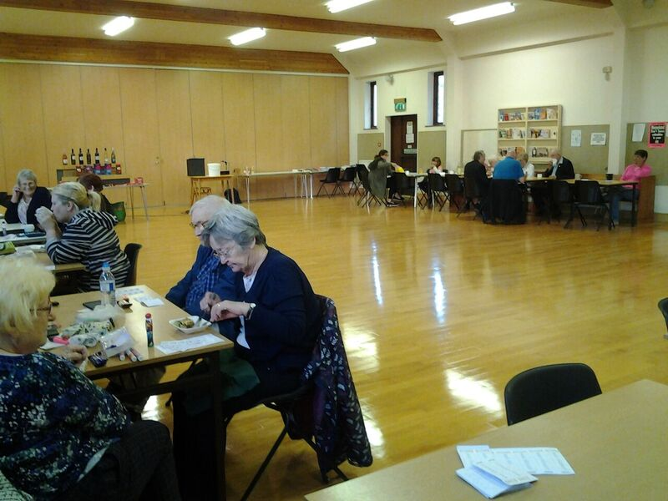
Pie & Pea evening

The hall hosts a dancing class for adults once a week and it is hoped to encourage more people to use the hall both as a means of attracting people to the faith, and to increase our income.

The York School of Ministry meets weekly here offering a course which is taken by candidates for Reader ministry from across the archdeaconry, and which is also open to anyone who wishes to follow it. There is a well-stocked study library in one of the church hall rooms.

Mission possibilities in East Middlesbrough
The parish of the Ascension has a key part to play in the Deanery action plan for East Middlesbrough as it borders the parishes of St Thomas Brambles Farm, St Cuthbert’s Ormesby and Holy Trinity North Ormesby, whose parish centre is a resource for the whole deanery. The new priest at the Ascension would have a key role alongside Rev. Jennifer Croft and Rev. Terry Leathley (the parish priests of Ormesby and Brambles Farm respectively). We have an excellent team and buildings available at the Ascension to play an integral part in the exciting things happening in East Middlesbrough, an area ranked as one of the 10% most deprived parishes in England and so a focus for the Diocesan strategy to ‘Reach the people we currently don’t’.
At present we donate to the Food Bank but due to the facilities within the church there is an opportunity to be more involved.
There may be the possibility of a Youth Club based at Berwick Hills due to the success of the club in Brambles Farm run by Christian Youth Workers.
At one of our Deanery Fellowship meetings a talk was given on Alzheimer friendly Cafés. This could be another area we could be involved in.
Some of our congregation have attended social events for refugees in the East Middlesbrough Area.
We have a fully equipped kitchen that is not used to its full potential. We could promote a soup kitchen and advertise hiring the hall to various charities etc. which will boost our income.
Due to the links we have formed with care and retirement homes in our parish, working with the elderly will enhance our mission in East Middlesbrough and also provide the elderly with activities. We used to run a tea dance many years ago.
Two years ago we converted one of our narthexes to a chapel dedicated to St. Thomas now that the people of our neighbouring parish, Brambles Farm, have no building to worship in. Fr. Terry holds a service here once a month on Sunday at 11.30 am so that the identity of the St Thomas’ congregation is maintained.

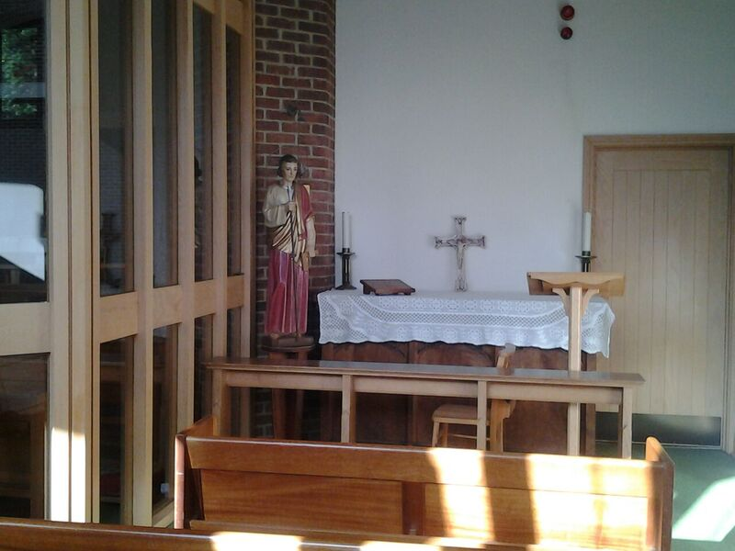

St. Thomas Chapel

Buildings

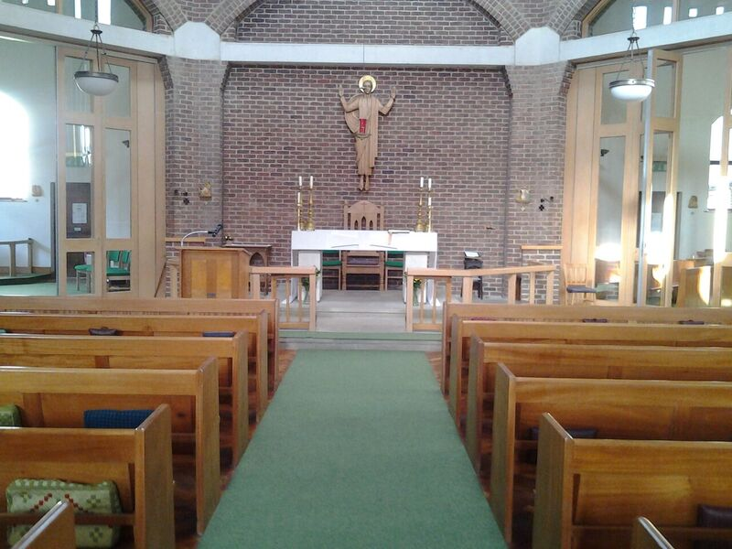
The Ascended Christ

The church building is only 20 years old but the church as a body of Christian people has existed much longer in this area. Meetings were first held in individual houses, then in a shed on the local allotment, before the building of a dual purpose hall. The first church building was dedicated in 1966.
The Rev. Ron Woodley was given the task of establishing the church in the area which he achieved successfully and the congregation became a vibrant, enthusiastic force in the local community. In 1966 the purpose built church was opened and the dual purpose building became the hall. With a succession of dedicated priests and committed laity, the church became a focus for the area and local population.
In 1997 as part of a complete reorganisation of the commercial and administrative links of the local area the PCC agreed to the demolition of the church building, the vicarage and hall to have the whole plant moved 250 metres along Penrith Road to a new site. The cost of the move was to be funded partly by European funding but primarily by an investment from Morrison’s who wished to construct a new supermarket on the location of the church. As a result the parish was provided with a new church, new vicarage, new curate’s house and a modern hall. This remains an excellent springboard for the future development of the parish. The design of the new building is unusual in that the central part is octagonal in shape, set in an outer square, so that the spaces between the inner and outer walls form eight individual areas. These include two chapels, a sacristy and vestry, an open baptistery, an office, two narthexes and an entrance to the corridor leading to the hall. The pews and statue of the risen Lord above the altar were brought from the first church. The hall is large with a wooden polished floor, the screens close off the stage area. The kitchen is fully fitted. A meeting room, library and toilets open off the corridor.
The four bedroomed vicarage and gardens at the rear of the church are currently being refurbished and the curate’s house at the front has been kept in excellent order by the tenants who occupy it at the moment. Both houses have gardens and the forecourts are paved

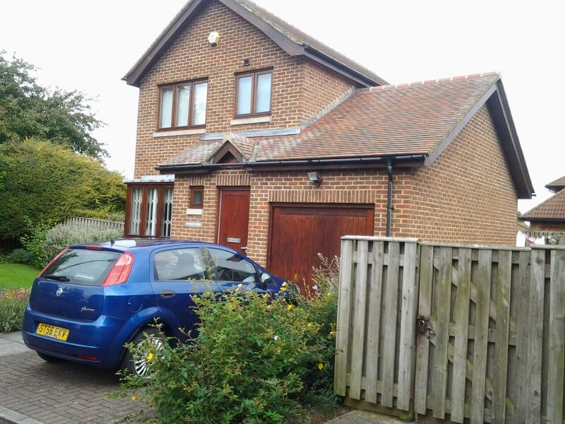
The Curate’s House

Financial position

As with many parishes the Church of the Ascension has in the past five years seen a decline in the congregation and as a result a reduction in direct giving to the church. At the same time expenditure has increased steadily and so at the present time the day-to-day finances are causing concern.
However, the parish is in the fortunate position of having sound investments. £50,000 was paid by Morrison’s when the church was built in 1997 to cover the cost of inconvenience of being without a church for 18 months. In addition the Transfiguration Pastoral Centre (a mission hall at the other end of the parish) was later sold for a further £50,000. The funds were invested in the CBF. The church building and hall, being relatively new, are in excellent condition and unlikely to require any significant works in the medium term.
So at the present time the parish does have a sound platform for further development and mission.

Style of leadership we are looking for
- To work closely with other Priests in the East Middlesbrough area and in the deanery generally.
- To lead us in study of the Bible and teach us the faith.
- Go out and meet with people within the Parish.
- Encourage congregation to work as a team.
- Firm but fair and give praise and credit when it is warranted.
- Be forward thinking and willing to share with his team at all times.
- Have regular meetings with the team.
- Able to delegate.
- Plan Church Festivals in advance.
- Fun loving with a good sense of humour, it’s a Northern trait.

The Wider Picture

A Brief History of Our Town

Middlesbrough’s history stretches back some eight centuries, when the very first settlement was a daughter monastery of Whitby Abbey. The name comes from ‘middle place’ as it stood between Whitby and Durham. We have a rich history of the northern Christian Saints like Cuthbert, Hilda and Aidan. The monasteries of Rievaulx and Byland are just a few miles away. The surrounding areas are beautiful with the hills and moorland of the North York Moors National Park, and pleasant beaches along the North Sea coast.

Middlesbrough lies on the south bank of the River Tees, and was given its status as a Municipal Borough in 1853, but there was a port and small settlement here from 1850. Described as the ‘Infant Hercules’, it drew families from all over the country with the development of the iron and steel industry, shipbuilding and the advent of the railway. We are proud of our industrial heritage - Middlesbrough’s iron and steel industries helped build some of the world’s most iconic structures including the Sydney Harbour Bridge which was designed and built in Middlesbrough. Although it is still described as an industrial town, much of the industry has closed down leading to high unemployment in some areas of the town. However, many people are still employed at I.C.I. the local chemical works and the Council is investing in new digital and leisure industries to renew our economy.

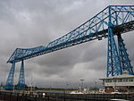
The town boast good shopping areas, libraries, a museum and art gallery and theatre. The further education centre has now been given university status, while the James Cook University Hospital has national recognition as a centre of excellence. There are good transport links by road and rail, and a famous feature of our town is the Transporter Bridge linking us with Port Clarence by a moving platform suspended by cables.

The Deanery

The Middlesbrough Deanery is made up of seventeen parishes with a variety of different traditions. The Deanery covers a wide area from Thornaby in the west, across Middlesbrough to Grangetown in the east. Over recent years the parishes in the Deanery have begun to work in a more co-operative and collective way with the Area Dean and the Deanery Standing Committee developing a Mission Plan which includes a strategic planning group being established.

Clergy and laity have begun to work across parish boundaries and co-operate in mission initiatives. Five years ago a Deanery Fellowship was started by members of our congregation here which involves monthly meetings with interesting speakers. The aim of the fellowship was to cross parish boundaries and share faith and ideas of other Christians in our town so that we can support one another.

A Deanery Conference was held in 2016 with more than 90 parish representatives attending and the level of optimism and enthusiasm for developing mission in urban parishes was encouraging. In recent years the Deanery has been at the forefront of developing a number of practical initiatives. The network of Food Banks has been established throughout the area and key members of the Deanery have been at the centre of the church’s positive response to refugees and asylum seekers.

The Deanery has identified priorities for mission in the area and these have included the urgent need for new churches in Coulby Newham and Brambles Farm. There will also be a focus on working productively with Middlesbrough College and the University of Teesside and their student bodies, and the extension of mission to the elderly within the Deanery.

Thank you for reading our Benefice and Parish Profiles
If you would like to have an informal conversation about this post, please contact the Bishop of Whitby, the Rt Revd Paul Ferguson (01642 593273), or the Archdeacon of Cleveland, the Ven Samantha Rushton (01642 706095).

The post is open to male priests of the Church of England or a church in full communion with it. The presentation to the living has been Suspended as there will need to be discussions, involving the appointee, about the longer-term appropriateness of the present parish boundaries (though it is not anticipated that there will be an effect on the parish priest’s workload). It is intended that the appointee will be confirmed as Incumbent when those discussions are complete. Appointment is subject to a satisfactory Enhanced DBS disclosure.

You are invited to use the standard Church of England application form which may be downloaded at
https://www.churchofengland.org/media/2288914/application_form.doc
Completed forms should be sent to the Bishop of Whitby’s PA, Mrs Mandy Robinson
Mandy.robinson@yorkdiocese.org
21 Thornton Road, Stainton, Middlesbrough TS8 9DS

The closing date for applications is 12 noon on 11th October 2017, interviews 2nd November 2017

